MultiFEBE

Tutorial 11: harmonic analysis of an arch dam. Compliant base model

J.C. Galván and L.A. Padrón

April 2023

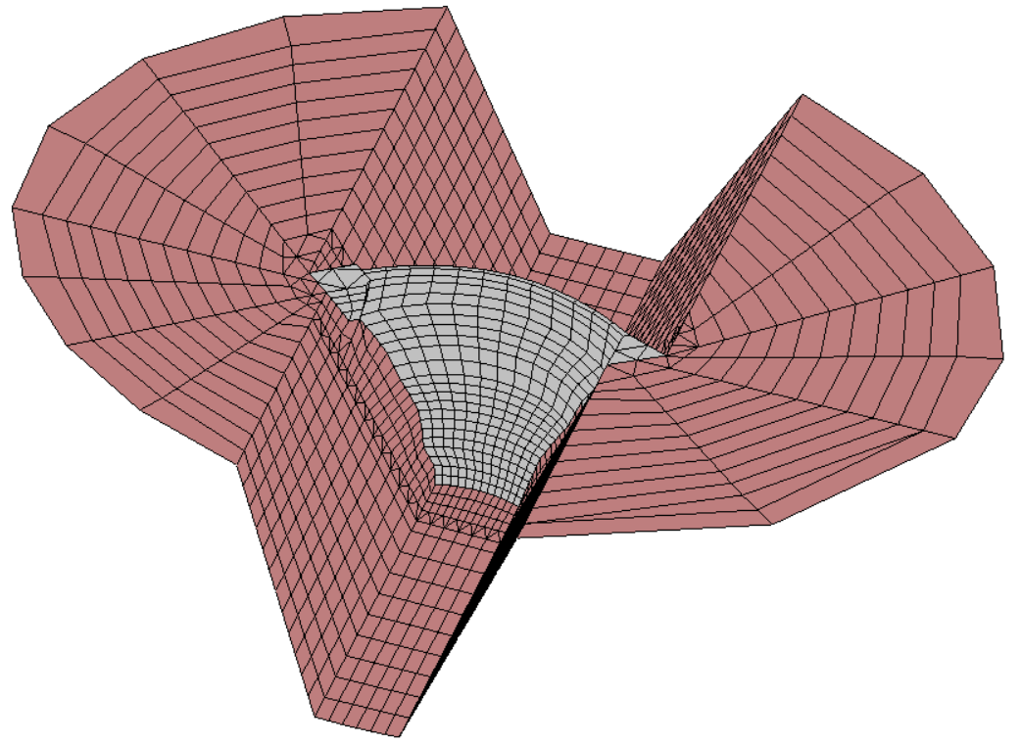
(a)
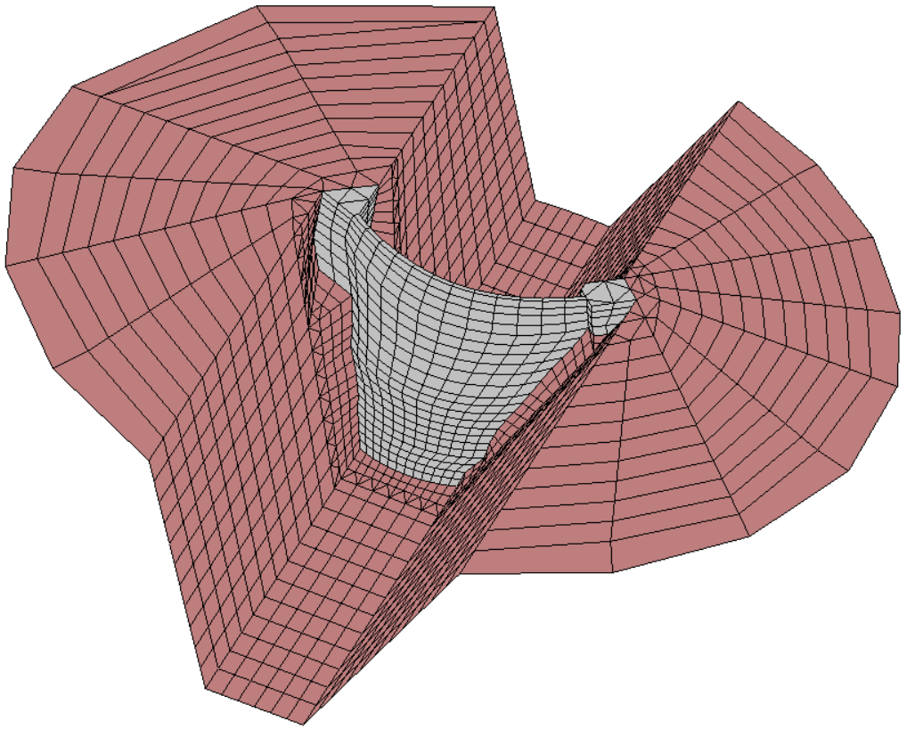
(b)
Figure 1: 3D mesh used for the BEM analysis. Dam wall embedded in a prismatic canyon with an extension of the free-field discretization of 240 m. (a) Downstream side view. (b) Upstream side view
1 Problem description

In this eleventh tutorial, a harmonic analysis of an arch dam is performed using the Boundary Element Method (BEM). Figure 1 shows the boundary element mesh used for the compliant-base model analysis where the dam wall is embedded in a prismatic canyon with an extension of 240 m.

The model was impinged by seismic time-harmonic plane waves. For this analysis, it was assumed that the incident wave field consists solely of plane SH waves propagating vertically with a horizontal direction of the y-axis free-field ground surface motion (Fig. 2.a) in order to calculate the frequency response function (FRF) at a node located at the midpoint of the dam crest (Fig. 2.b).
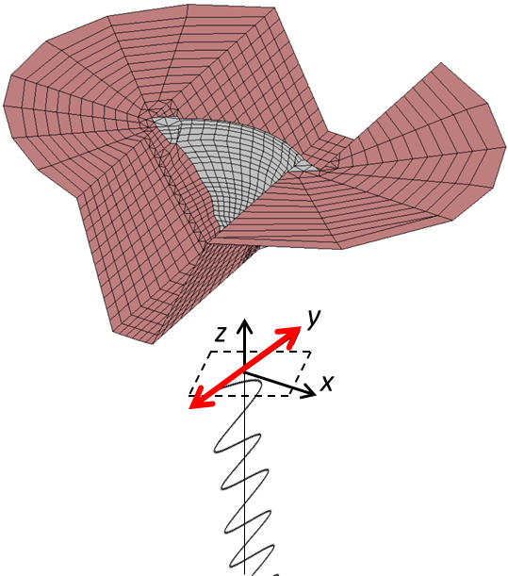
Plane SH waves
Direction of the
y-axis ground motion

(a)
Study node
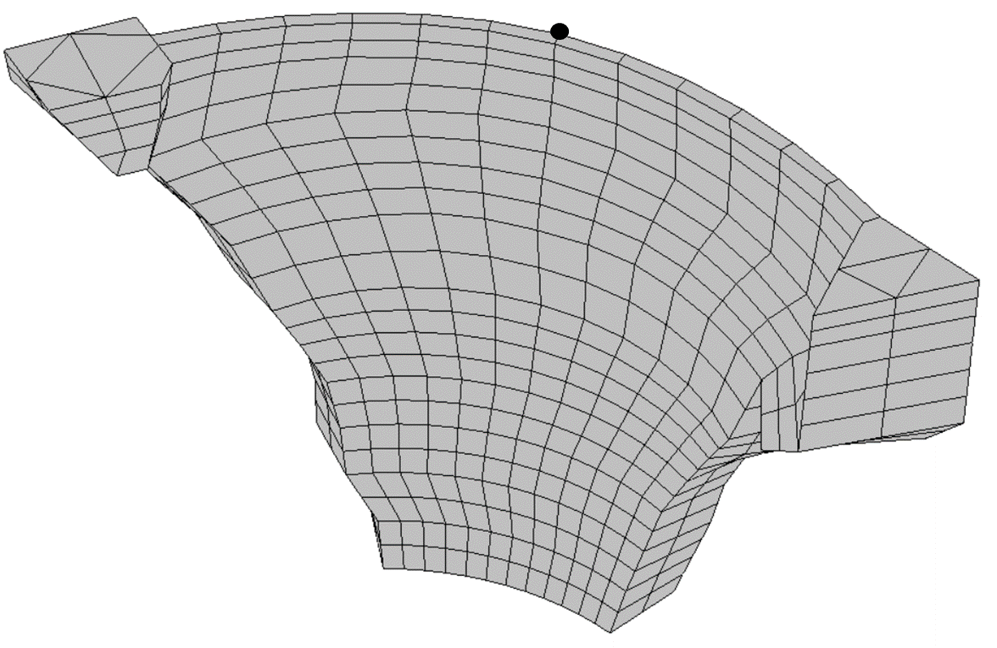
(b)
Figure 2: (a) Excitation along the y-axis direction. (b) Study node

The concrete dam wall and the foundation rock material are assumed to be viscoelastic with the properties shown in Table 1 [1, 2].
Property | Dam concrete | Foundation rock
Young’s modulus (elastic modulus), E (MPa) | 19599.92 | 28999.99
Mass density, ρ (kg/m3) | 2300 | 2143
Poisson’s ratio, υ | 0.2 | 0.2
Internal damping ratio, ξ | 0.01 | 0.01
Table 1: Material properties

2. Pre-processing

In the same way as in tenth tutorial, the mesh is generated from the GiD program and the BE mesh consists of nine-node quadratic quadrilateral elements and six-node quadratic triangular elements

2.1 Mesh generation with GiD

In this problem, seven layers (or boundaires) are defined, one per contour (Fig. 3, layer name in red box).

Crest  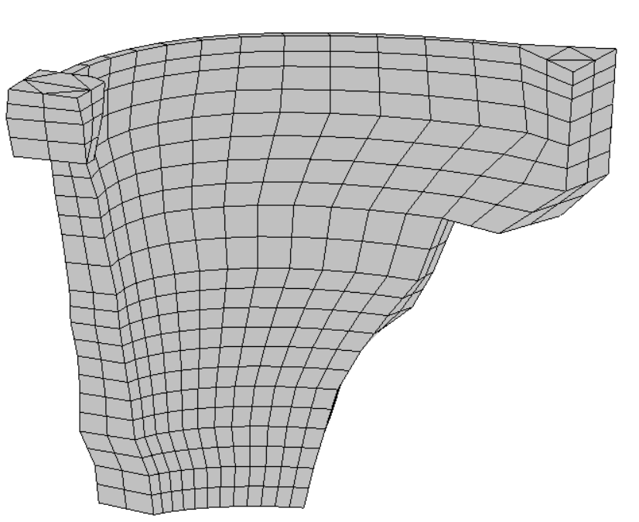  Downstream_face  Right_abutment  Left_abutment | Upstream_face  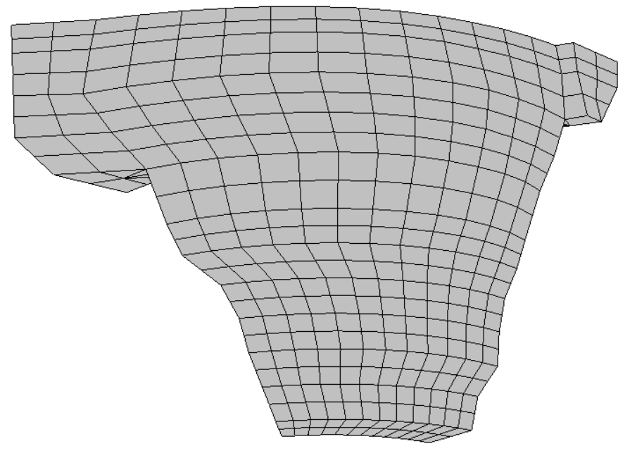  Foundation
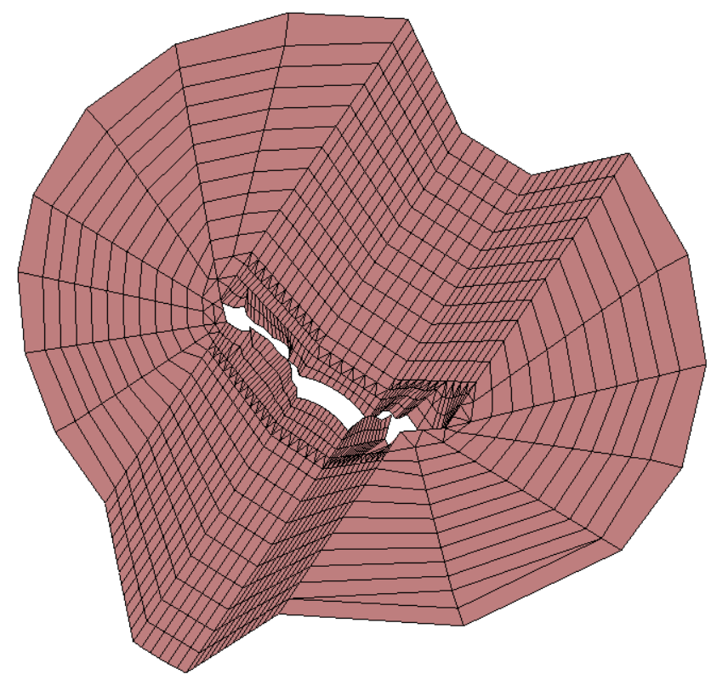
Foundation_rock

Downstream

Upstream

Figure 3: Layers (or boundaires) used for the BEM analysis
It is worth noting that the nodes common to two, three or four contours will be duplicated and they will have different numbering (Fig. 4).

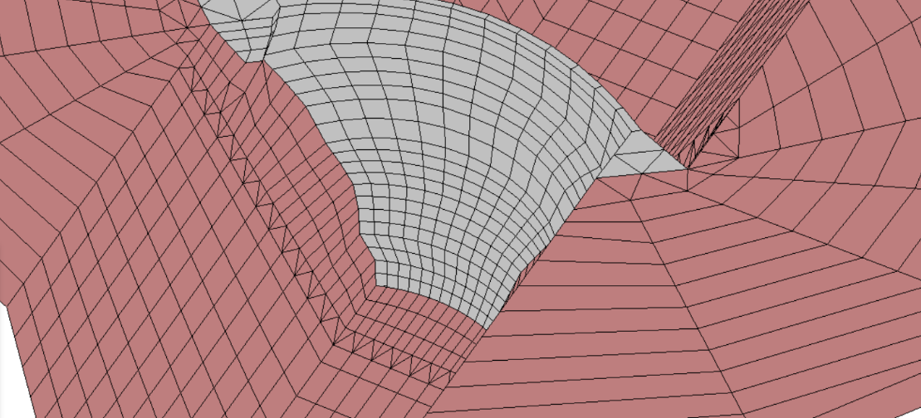

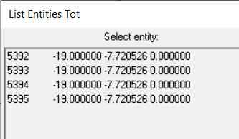

(a)
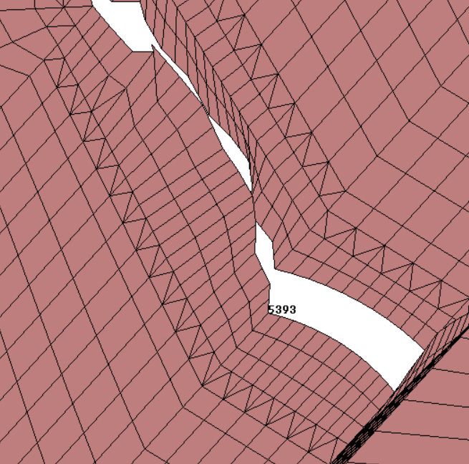  (b) | 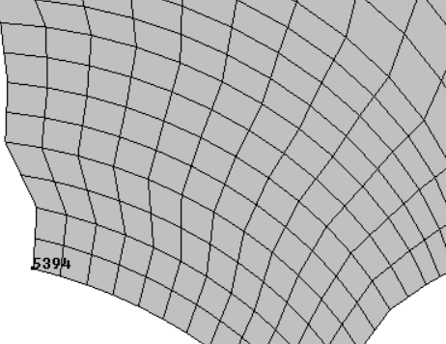  (c) | 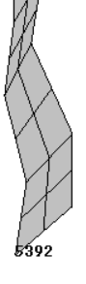  (e)
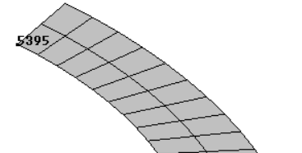
(d)
Figure 4: (a) Example of duplication of nodes. Node belonging to four contours: (b) foundation rock, (c) downstream face, (d) foundation and (e) left abutment

Once the mesh is generated, it is written in GiD native MultiFEBE format using the implemented template file *.bas shown in the MultiFEBE Reference Manual (Appendix C).

Finally, the file generated contains nodes, elements and parts of the mesh which, in this example, will be copied and pasted in the input data file.

  - Input data file

The first part to configurate is the problem definition in the section [problem]. This example is a 3D harmonic mechanical problem.

[problem]
n = 3D
type = mechanics
analysis = harmonic

Then, a list of frequencies is generated by specifying the number of frequencies. It has been defined an analysis of 115 frequencies, from 0.01 Hz to 6.9 Hz.

[frequencies]
Hz
list
111
0.01
0.1
0.2
.
.
.
6.7
6.8
6.9

As mentioned, the mesh is going to be read from the same input file, so sections [nodes], [elements] and [parts] must be written in the script.
[nodes]
8168
1 8.813571200000000e+01 2.232310379091612e+02 1.200000000000000e+02
2 8.549317964866341e+01 2.239077006388230e+02 1.145454545454546e+02
.
.
.
8167 -1.552369308781168e+01 -2.394968937132634e+02 0.000000000000000e+00
8168 -1.900000011251359e+01 -2.392467345560321e+02 0.000000000000000e+00

[elements]
2023
289 tri6 1 1 6153 6220 6234 6185 6228 6190
291 tri6 1 1 6372 6497 6402 6435 6448 6387
.
.
.
2022 quad9 1 7 680 665 730 748 670 700 735 716 703
2023 quad9 1 7 748 730 805 828 735 770 812 789 778

[parts]
7
1 Downstream_face
2 Upstream_face
3 Left_abutment
4 Right_abutment
5 Foundation
6 Crest
7 Foundation_rock

In this example the nodal solutions will be exported. For it, the section [export] takes the form

[export]
complex_notation = cartesian
nso_nodes = 1 2016

where the complex notation is set as cartesian and the result for specific node is taking by specifying the number of node (1) and the identifier of the node (2016).

As the problem has two materials, the section [materials] will need three lines: a first line for the number of materials in the model and a line per material with their properties such as tag, type, E, ρ, ν and ξ.

[materials]
2
1 elastic_solid E 19599921600. rho 2300. nu 0.2 xi 0.01
2 elastic_solid E 28999999999.92 rho 2142.85 nu 0.2 xi 0.01

In the next section [boundaries], it is necessary to specify the number of boundaries in the first line, and a line per boundary by indicating the boundary identifier, the identifier of the part that discretize it, and finally the boundary class. In this example there are 7 boundaries: boundary 1 is the part 1 of the mesh, boundary 2 the part 2, boundary 3 the part 3, boundary 4 the part 4, boundary 5 the part 5, boundary 6 the part 6 and boundary 7 the part 7 and all of them are ordinary boundaries.

[boundaries]
7
1 1 ordinary
2 2 ordinary
3 3 ordinary
4 4 ordinary
5 5 ordinary
6 6 ordinary
7 7 ordinary

In this example, in the section [bem formulation over boundaries], the collocation strategy in the seven boundaries must be nodal, with the exception of boundaries 5 and 7, where a non-nodal collocation strategy is prefered for all the nodes along its boundaries, with a displacement towards inside each element of 10% the width of the element. In this case, one should write:

[bem formulation over boundaries]
boundary 1: sbie
boundary 2: sbie
boundary 3: sbie
boundary 4: sbie
boundary 5: sbie_boundary_mca 0.01
boundary 6: sbie
boundary 7: sbie_boundary_mca 0.01

The format of the [regions] section consists of a first line indicating the number of regions, 2 in this case. For each region there is a block of data consisting of several lines of data. The first line of each block is the region identifier and the region class (1 be and 2 be, for the first and second region, respectively). As the regions are a BE regions, the second line indicates the number of boundaries and a list of boundaries, with their orientation signs (6 1 2 3 4 5 6, for the first region; and 4 -3 -4 -5 7, for the second region). The third line of each block defines the material while the fourth line defines the number and a list of BE body loads (0 in this case). Finally, the fifth line defines the number and a list of incident fields (0 for the first block; 1 1 for the second block). The format of the section is:

[regions]
2

1 be
6 1 2 3 4 5 6
material 1
0
0

2 be
4 -3 -4 -5 7
material 2
0
1 1

Now, in the section [incident waves] the incoming waves are defined. The general format has a first line for the number of waves (1), a second line for the wave identifier (1), a third line for the wave class (plane), a fourth line for the space (half-space with np = 3 (3D case), xp = 120.0 (foundation rock height), bc = 1 (3D case)), a fifth line for the variable (0 for displacement), the amplitude (1.,0.), the reference point (x0(1) = 0., x0(2) = 0., x0(3) = 0.) and the angles (varphi = -90., theta = 90.), a sixth line for symmetry options (xs(1) = 0., xs(2) = 0., xs(3) = 0., symconf(1) = 0., symconf(2) = 0., symconf(3) = 0.) and a seventh line for the region type (viscoelastic) and the wave type (sh). So, the format of the section takes the form:

[incident waves]
1
1
plane
half-space 3 120.0 1
0 (1.,0.) 0. 0. 0. -90. 90.
0. 0. 0. 0. 0. 0.
viscoelastic sh

- Results and discusión

3.1 Nodal solutions file (*.nso)

The FRFs of the study node computed with the harmonic analysis using two different softwares (Aznárez et al. [3] and MultiFEBE) are plotted in figure 5. As mentioned, the system excitation consists of the y-axis free-field ground surface motion (Fig. 2 (a)).

Firstly, in figure 5 it can be seen a very good agreement between the softwares employed. It can be also observed two peaks clearly captured at 4.75 and 6.11 Hz, approximately, which correspond to the dam wall second and third natural frequencies, respectively, under y-axis excitation in compliant base model direction (Galván et al. [4]). By other hand, figure 6 shows the real (a) and imaginary (b) parts of the FRFs of the study node where it can be also observed a very good agreement between the softwares employed.
Figure 5: FRFs. Transversal response of the midpoint of the dam crest

(a) | (b)
Figure 6: Real (a) and imaginary (b) parts of the FRFs of the study node
Figure 7 presents the comparison of the first two symmetrical modal shapes along the dam crest computed from the two softwares mentioned before, where it can be also observed that the agreement between the two modal shapes obtained from them is very good.
(a)  SECOND MODE SHAPE (4.76 Hz) | (b)  THIRD MODE SHAPE (6.15 Hz)
Figure 7: Comparison between the first two symmetrical modal shapes along the dam crest using two different softwares

3.2 Gmsh results file (*.pos)

In this section, the dam wall second and third mode shapes of vibration, this is, the first two symmetrical mode shapes of vibration will be plotted using the Gmsh software with the output file obtained from MultiFEBE code following the steps showed in tenth tutorial.
ç
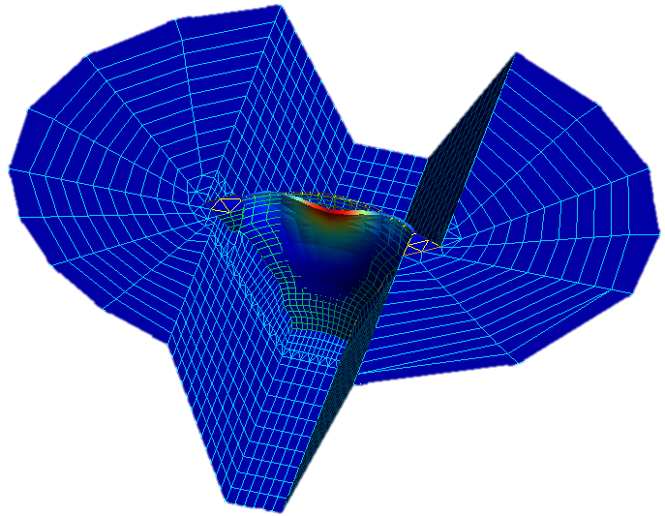
Figure 8: Second mode shape of vibration (4.76 Hz)

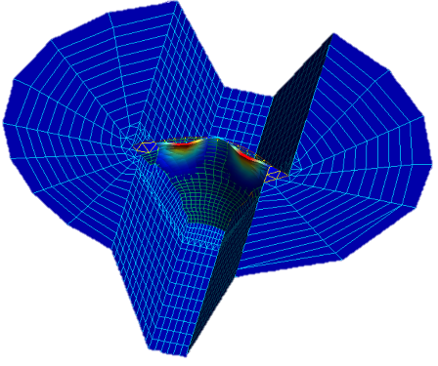
Figure 9: Third mode shape of vibration (6.15 Hz)

References

[1] Documento XYZT. Presa de Soria. Tech. rep., Dirección General de Obras Hidráulicas. Ministerio de Obras Públicas y Transportes; 1991.

[2] Infraestructura de datos espaciales de canarias. Modelo de terreno LIDAR. 2017, http://www.idecanarias.es.

[3] J. J. Aznárez, O. Maeso, and J. Domínguez. BE analysis of bottom sediments in dynamic fluid-structure interaction problems. Engineering Analysis with Boundary Elements, 2006, 30:124–136

[4] J. Galván, L. Padrón, J. Aznárez, O. Maeso, Boundary element model for the analysis of the dynamic response of the Soria arch dam and experimental validation from ambient vibration tests. Engineering Analysis with Boundary Elements, 2022, 144: 67–80

